Cortisol
Chemical Formula: $C_{21}H_{30}O_{5}$
Molar Mass: 362.46 g/mol
Functional Group: Ketone, Alcohol, and Alkene
Description: Cortisol is one type of steroid hormone that produce in the cortex of adrenal gland. (3) Stress can effect the level of cortical in the body. Activation of the pituitary-adrenal axis is a prominent neuroendocrine response to stress, promoting survival. (1)
Function: Cortisol have a different functions depend on which cell cortisol is acting on because most of the cell contains cortisol receptors.(2) Such as, controlling sugar levels in the blood, regulating metabolism, anti-inflammatory, influencing memory formation, controlling salt and water balance, influencing blood pressure, allow kidney to produce hypotonic urine and helping development of the fetus. (3)
Physical and Chemical Properties: (4)
State | Solid
Color | White, crystalline powder
Odor | Odorless
Taste | Bitter
Melting Point | 220 °C
Formal Charge | 0
Heavy atom count | 27

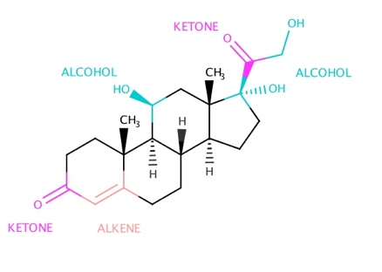
Structure:

References:
1.Ranabir, S., & Reetu, K. (2011). Stress and hormones. Retrieved May 21, 2017, from https://www.ncbi.nlm.nih.gov/pmc/articles/PMC3079864/
2.Cortisol. (n.d.). Retrieved May 21, 2017, from http://www.yourhormones.info/Hormones/Cortisol.aspx
3.What is Cortisol. (n.d.). Retrieved May 21, 2017, from http://www.hormone.org/hormones-and-health/what-do-hormones-do/cortisol
4.Hydrocortisone. (n.d.). Retrieved May 21, 2017, from https://pubchem.ncbi.nlm.nih.gov/compound/hydrocortisone#section=Top

.

